**About**

I am currently studying a Master of Engineering (Software Engineering + Business) with a keen passion on technology and its impact on healthcare. My current career goal is to stay positive and learn continuously, with the end goal of becoming a full-stack developer that makes a difference.

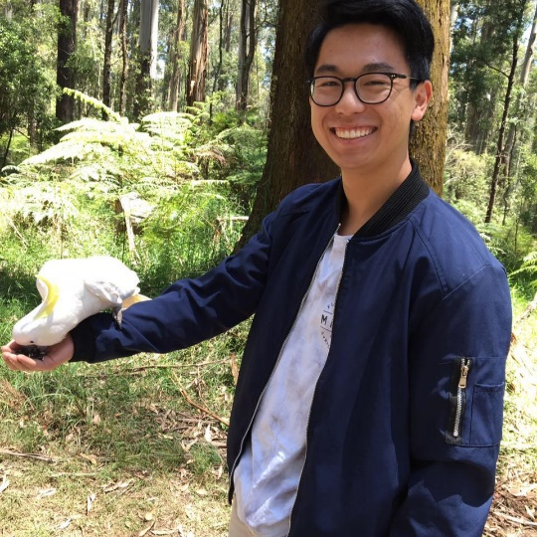

Hi, I’m   
**Charlie Ding**

SOFTWARE DEV

**Projects**

(Discord Bot) (Expense Tracker Flask-based) (Hackathon…) (Coming soon…)